CCPS510 - Assignment 2

Summer Camp Database

Rui Zhang - rui2.zhang@torontomu.ca - 500736315
Johnathan Spinelli - jspinelli@torontomu.ca - 501410059

DELETE THIS SECTION BEFORE SUBMISSION

Files needed for the Zip:
- An updated version of the milestone submission reflecting any changes made through the design process and including any design decisions that potentially impacts the business rules (example: we decided to add a bridge table between the ___ table and the ___ table, even though it is a 1-to-many relationship, such that we can add additional flexibility in the design for future scalability and potential business rules exceptions).
- A Completed ERD or Schema Diagram (draw.io)
- A single SQL file Table Creation Script including the creation of all tables and constraints in the database. (Do not forget to add Primary Keys, Foreign Keys, DEFAULT ,check constraints if/when needed) More the better
- A single SQL file Data Insertion Script for inserting sample test data.
- A single SQL file which has SELECT Reporting Creation Script for creating the required reports providing easy data presentation (You choose these reports to show us some details)

Things needed in this document
- A paragraph briefly describing the topic and the providing a problem statement,
- A paragraph stating how the database will assist in providing the solution,
- A paragraph how the database will fit with other potential parts of the system architecture to provide a complete solution (i.e. the database will be accessed though a _____ to provide data to _____ for use in the _______.) It is expected that the database will be part of a complete software process, even though group’s will only be designing and developing the database only.
- A point form list, or table format, of the business requirements/rules for your project

Project Summary
Topic description
Many kids attend summer camps as a way of spending time outdoors, developing new skills and making new friends. These summer camps often have a lot of planning in order to make things run smoothly, as there is a lot of responsibility placed on the coordinators watching over a large group of children in the wilderness. Outdoor summer camps often have activities for campers to sign up for, allowing them to customize their own camp experience and prevent campers from being forced into activities they don’t want to participate in. Some camp organizations like to reward students for participating in activities by providing them with a reward, often in the form of a badge representing some displayed skill. The database solution will provide structure to the camp organizers, allowing for recording participant information and planning events held throughout the duration of the camp.

Database solution
The database solution will be designed to track information about each of the campers and their associated guardian/emergency contact should anything happen to the campers. The system will be able to represent their camping experience, tracking any events they participate in and any associated badge they will receive. On the other hand, the database will be beneficial for administrative staff to keep track of which counsellors are running each event, which campers are joining them, where the activity is taking place, when the event is scheduled for, and the equipment required for each activity. The database will also be useful to keep a digital record of the badges earned by each camper, able to be updated anytime a camper completes an activity worthy of a badge.

Database integration
The database would be designed for many different involved parties to access through a webpage. The administrative staff can use a form to collect the information from all the counsellors, inserting the info into the database. Parents would be able to use a separate webpage to register their children for camp and signing them up for their weekly activities. Parents would also be able to view their camper’s progress, watching as they collect badges and changing their schedule on the fly, as needed. Assuming the counsellors have internet service on the campground, they would be able to access the updated list of campers attending their scheduled event and ensure that they have all the equipment with them before starting the activity. In case of any form of emergency, the administrative staff and counsellors would be able to reach any camper based on where they should be at any given moment. At the end of the week, when the guardians come to pick up their children from camp, the counsellors will use the webpage to ensure the ID of the person matches their registered guardian.

Business Rules - Review before submission
- counsellors have exactly one address, and campers have exactly one address, but an address may belong to many counsellors and/or campers. An address cannot exist without an associated counsellor or camper.
- A camper has exactly one guardian, and a guardian can belong to multiple campers
- counsellors can lead many events, and every event has exactly one counsellor leading the event
- An event has one corresponding activity, but an activity may be run for many events.
- Each event takes place at a campground location, and a location may be used for many different events.
- An activity may only have one badge associated with it, but a badge may be associated with many activities.
- A camper may earn many badges, and a badge may belong to many campers. It’s also possible that a rare badge exists that no campers have earned yet.
- A camper can register for many events, and each event can have many campers registered. This N:N relationship can be solved with an event registration entity, where a camper can register many times, but each registration is associated with a single camper. An event may have many registrations, but each registration is for a single event.
- An activity may have many equipment items, but each item belongs to a single activity.

Normalization
The database has a lot of entries and fields to keep track of. Through normalization, we were able to determine how to best divide our data into separate tables. The normalization process helped us refine the writing of our business rules, which enforce the relationships between separate entities. For example, by dividing information about badges into a separate table, we were able to properly define a relationship between badges and the campers who have earned them.
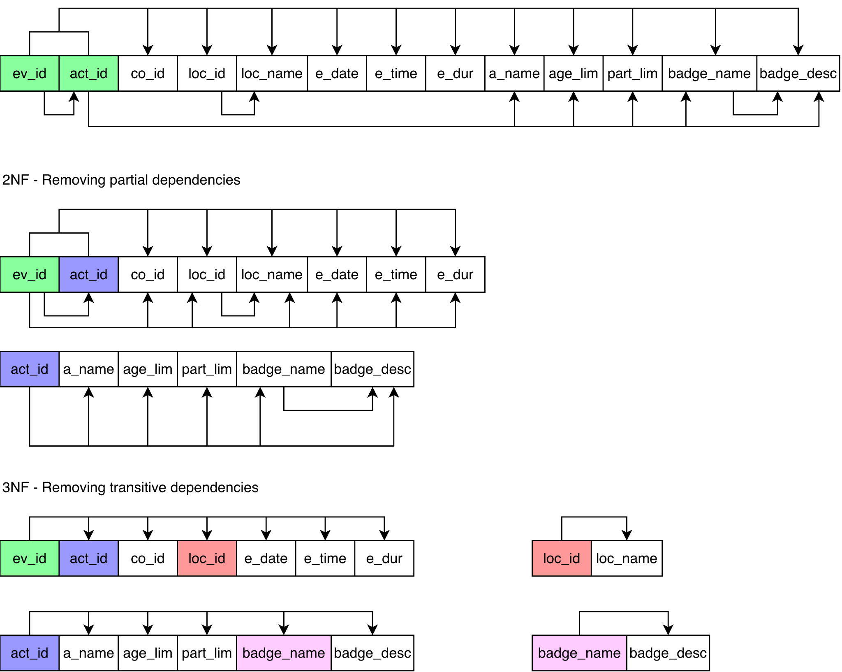

The names in the above diagram are different from their actual names in the database for convenience in fitting them into boxes. The diagram illustrates the normalization of our event data, splitting into a separate activity table which can be the activity for many different events (at different times, locations, etc). Other tables, such as the campers and counsellor, were intentionally designed to have a separate address entity for contact information.

